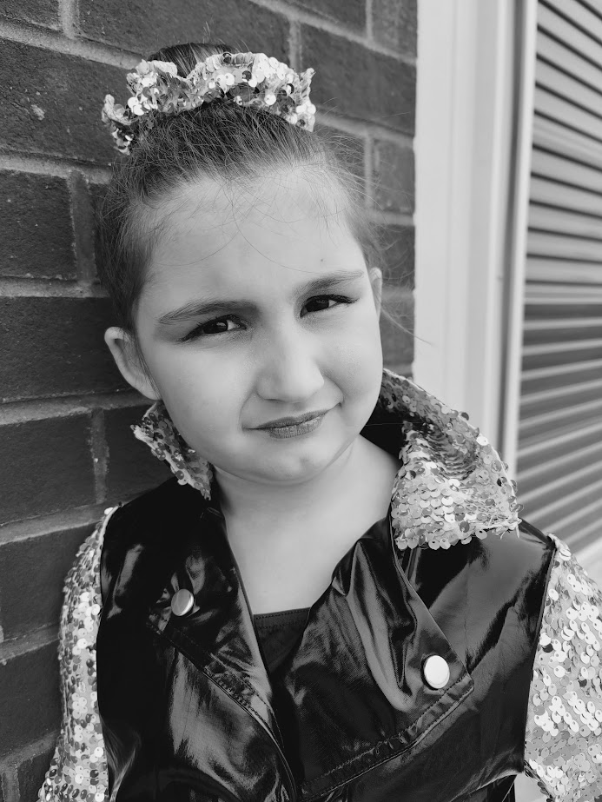 |  | Sydney Jones  Actor
Profile  I am a 9year old aspiring actor! I have lots of personality and charisma and I am looking for an opportunity to begin my acting career!  Contact  PHONE:  828-280-1110  EMAIL:  Scrofanijones@gmail.com  Hobbies  Dance  Archery  Violin  Art  Gem Mining |  | Training  Touch of Class Dance Studio Aug 2017-May 2018  Soar Dance Studio Aug 2018-May 2021  Pisgah Forest Dance Aug 2022- present  Acting Workshop with Ryan Kelley January 8, 2024  Acting Workshop with Ryan Kelley January 20, 2024  Acting Workshop with Jimmy Bellinger January 21, 2024

